GST Knowledge Base Access Manual

**Document status:** FirstDraft

**Created on:** November 22, 2024

**Last updated:** November 25, 2024

**Contact:** ITG Technical Writers, ITG Cross Functional

Contents

1 Overview 3

2 Business Scope 3

3 Audience 3

4 Accessing Knowledge Bases 3

4.1 Platform Overview 3

4.2 Platform Comparison 3

4.3 Accessing KBs on NetDocuments 4

4.4 Accessing KBs on ITSM-Ivanti 6

5 Best Practices 9

6 FAQs 9

1. What is the purpose of the GST Knowledge Base Access Manual? 9

2. Who is the intended audience for this manual? 9

3. How can I access the Knowledge Bases on NetDocuments? 10

4. What are the steps to access Knowledge Bases on ITSM-Ivanti? 10

5. What should I do if I encounter issues accessing the Knowledge Bases? 10

6. Can I bookmark the Knowledge Base folders for quick access? 10

7. How do I stay informed about updates and new documentation? 10

8. How can I request new documentation be created or update existing material? 10

9. How do I request access to a specific Knowledge Base? 10

10. What should I do if I need to correct information in a Knowledge Base? 10

11. Can I contribute to the Knowledge Bases? 10

12. How do I search for specific information within a Knowledge Base? 10

13. What are the best practices for maintaining Knowledge Bases? 11

14. How do I provide feedback on the Knowledge Base Access Manual? 11

15. What security measures are in place to protect the Knowledge Bases? 11

16. How do I stay updated on changes to the Knowledge Bases? 11

17. What should I do if I forget my login credentials for NetDocuments or Ivanti? 11

7 Revisions 11

8 Document History 11

9 Document Control Log 11

# Overview

This user guide assists the IT Support teams in accessing the support-related Knowledge Bases (KBs) about multiple domains across the available G+T platforms. It is intended for these cross-functional teams to ensure standardized information access across the organization.

# Business Scope

This guide outlines the procedures and methods for accessing and utilizing the Knowledge Bases available on NetDocs and Ivanti. It aims to streamline the process of retrieving and managing support-related information, ensuring that all team members have consistent and efficient access to necessary resources within the G+T IT ecosystem.

# Audience

The document is intended for the IT Service Desk, Infrastructure, and Infra EUC teams. It is also relevant for other ITG teams requiring access to support-related Knowledge Bases.

# Accessing Knowledge Bases

The available support knowledge base articles about different G+T domains are housed as a **centralized KB repository** in NetDocuments for team-wide access. Again, these individual pieces are sourced as URLs in the Ivanti KM module. Currently, two platforms to access these KBs are NetDocuments and Ivanti.

## Platform Overview

NetDocuments and Ivanti are integral platforms within the G+T IT ecosystem, providing document management and knowledge-sharing solutions. NetDocuments offers a robust, cloud-based document management system that enables secure access and collaboration on documents across the organization. Ivanti, on the other hand, specializes in IT asset and service management, providing tools for efficient knowledge management and problem resolution.

## Platform Comparison

Centralizing critical information in NetDocuments, which serves as the single source of truth, makes resolving issues easier and faster, improving service quality. Maintaining these Knowledge Bases in a broader platform like Ivanti enhances support operations. The approach ensures that support teams can access this information when needed and deliver consistent and accurate responses to user queries, boosting user satisfaction and operational productivity.

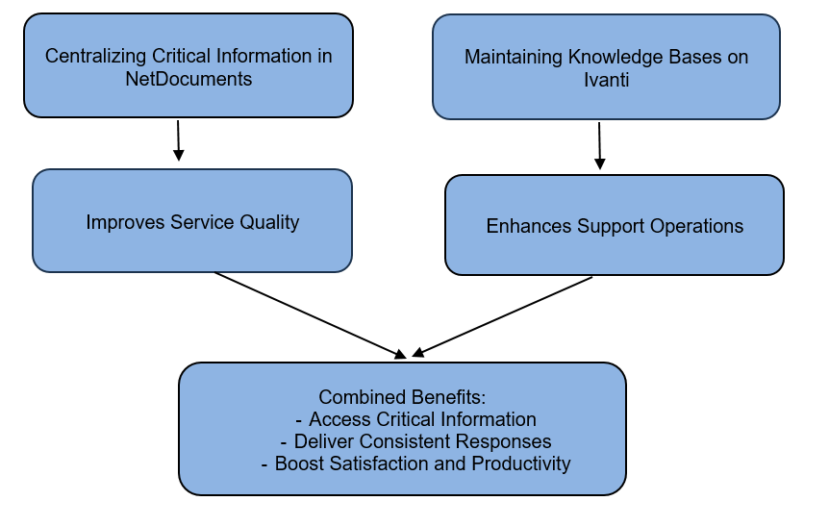

## Accessing KBs on NetDocuments

There are two primary methods to access KBs in NetDocuments:

* Accessing KBs using Direct Links (URLs)
* Accessing KBs using Folder Path

Each team has a designated link for accessing Knowledge Bases. Clicking these links will redirect you to the NetDocuments login page. Alternatively, you can navigate to [Home - NetDocuments](https://au.netdocuments.com/neWeb2/home) and locate the KBs using a specific folder path.

| **Team** | **Direct Link (URL)** | **Folder Path** |
| --- | --- | --- |
| Service Desk Team | [Official Documentation - NetDocuments](https://au.netdocuments.com/neWeb2/folder/:AU2:4:o:s:z:%5EF210623083159680.nev) | Business Cabinet > ITG – Service Desk > 0770210 Helpdesk > Official Documentation. |
| Infrastructure Team | [Infrastructure SOPs (Standard Operating Procedures) - NetDocuments](https://au.netdocuments.com/neWeb2/folder/:AU2:e:0:m:8:%5EF230825184632679.nev) | Business Cabinet > ITG – Infrastructure > Infrastructure SOPs (Standard Operating Procedures). |
| Infra EUC Team | [Knowledge Base - NetDocuments](https://au.netdocuments.com/neWeb2/folder/:AU2:r:r:2:b:%5EF240315192618589.nev) | Business Cabinet > ITG – Infrastructure EUC > Windows SOE > Knowledge Base. |

Clicking the direct link dedicated to a respective team will prompt you to log in to your NetDocuments account (if you still need to). Here are the underlying steps to follow:

**Step 1:** Click **Need login assistance**:

**Step 2:** Select **I want to use my organization’s login**, enter your G+T email address and click **Submit:**

**Step 3:** You will be redirected to the list of KBs page. Use the search bar at the top to find the desired KB by entering the most specific keywords, phrases, or the exact KB title (if known):

**Step 4:** Click the KB title to access and read the document. You may also download it by checking the document and clicking **more**:

**Tip**: For those requiring frequent access, consider bookmarking the relevant folders for quick and easy use. Keeping these resources at your fingertips ensures you can navigate and utilize the infrastructure tools and documents necessary for your role.

In addition to these resources, our team members are encouraged to regularly check for updates and new documentation to stay informed about the latest changes and improvements.

## Accessing KBs on ITSM-Ivanti

Making the most of these resources requires familiarity and regular engagement with the provided documentation. The approach ensures that all team members are well-informed and can operate efficiently within the G+T IT ecosystem.

Here are the steps to access the Knowledge Bases (KBs) on ITSM-Ivanti to aid in this.

**Step 1:** Go to <https://gtserviceco-ism.ivanticloud.com> and log in to your G+T account:

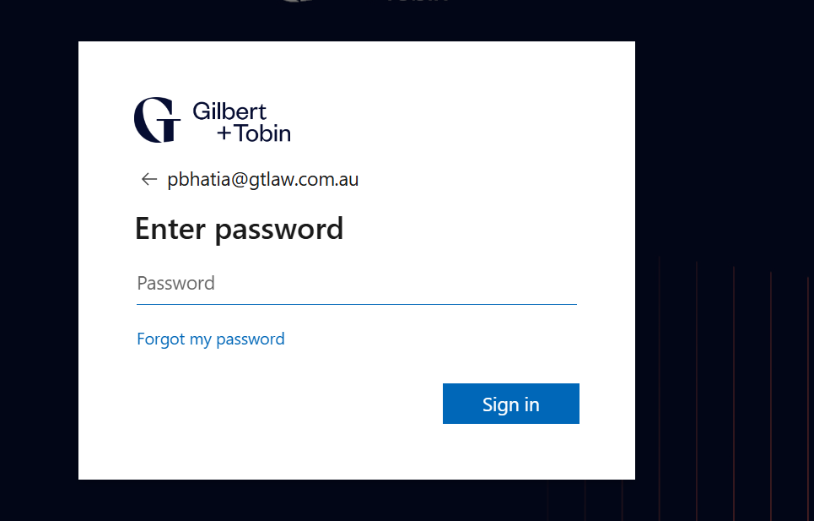

**Step 2:** Select the role of **Knowledge Manager** and click **Submit**:

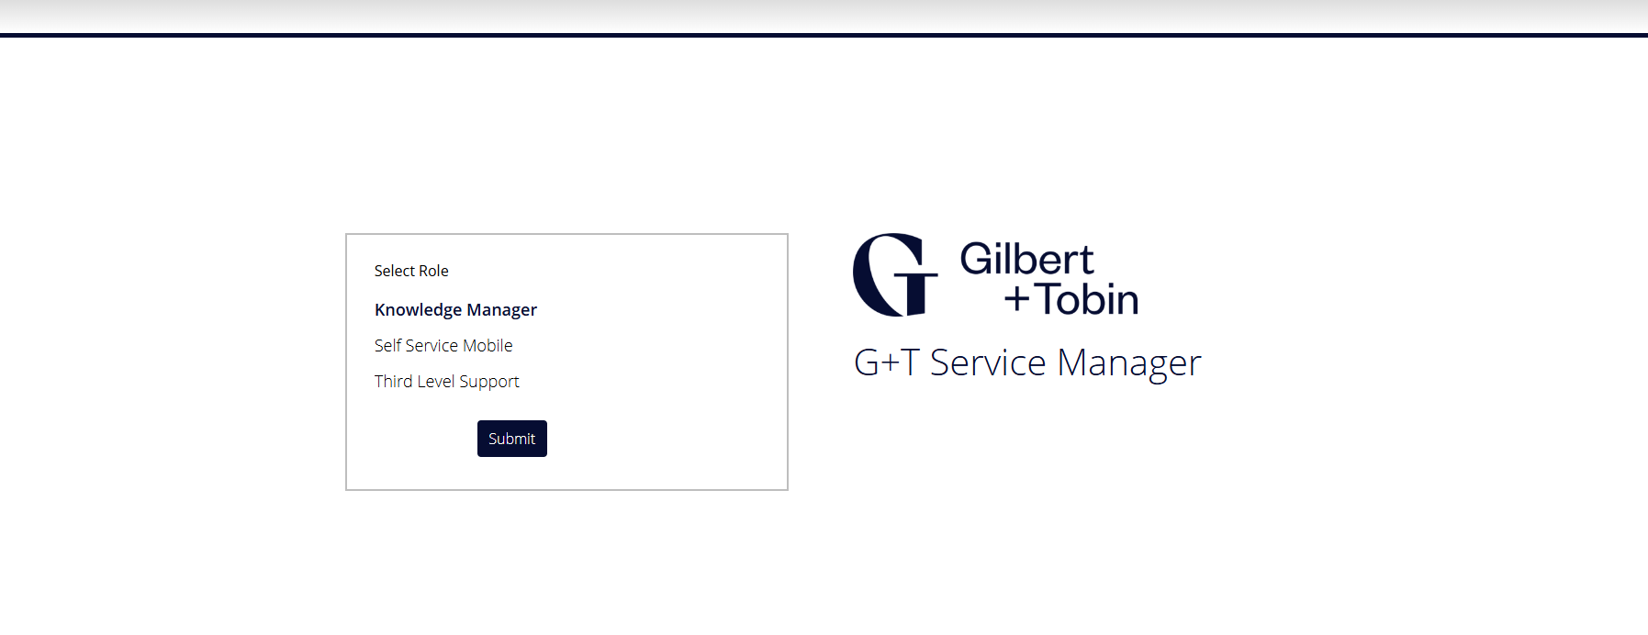

**Step 3:** Click the Knowledge tab and wait for the list of available knowledge bases to load:

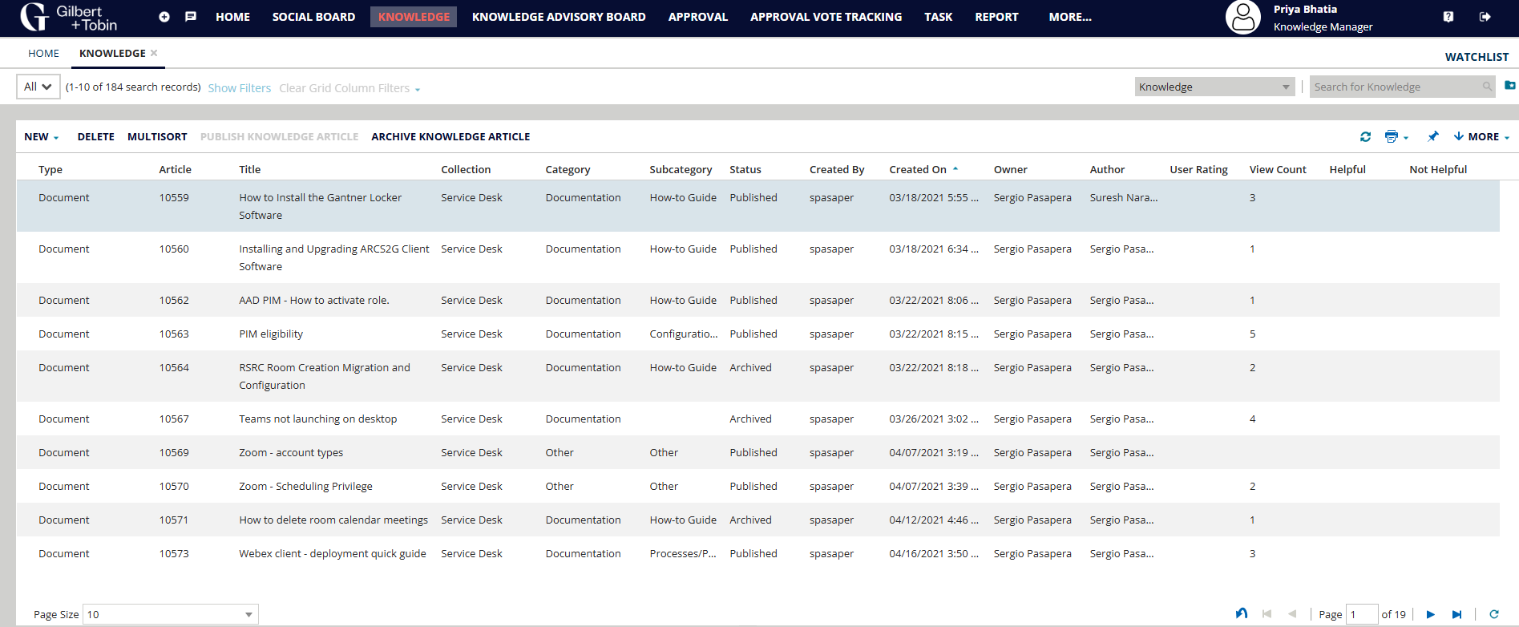

**Step 4:** Use the search function to locate the desired KB article you need by using the most specific keywords/phrases associated with your query/issue or KB title if known:

You can also filter the KBs by column value (e.g., category, subcategory, collection, status), then open the desired KB to access it:

**Step 5:** After locating the KB, double-click it to open the document:

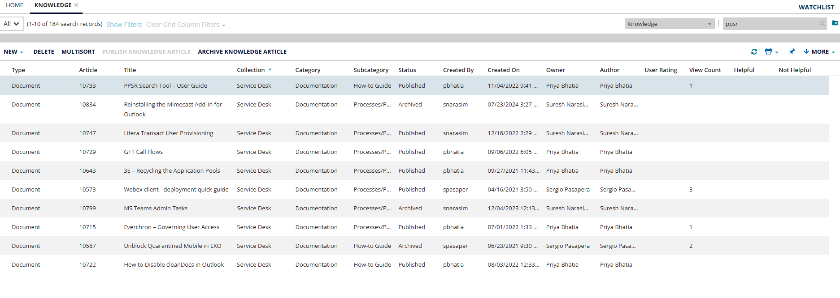

You will see the KB content below, including the NetDocuments repository URL as the single source of truth, in the description:

**Step 6:** Click the above URL, which will redirect you to the NetDocuments page where you can view the KB:

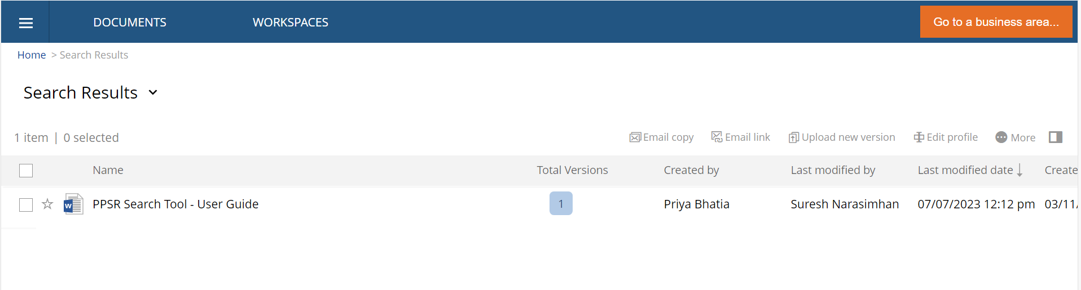

Carefully examine the content, paying particular attention to any highlighted sections or notes that may indicate recent updates or critical information.

If you encounter any discrepancies or require further clarification, do not hesitate to contact the ITG support or technical writing teams for assistance at:

[itservicedesk@gtlaw.com.au](mailto:itservicedesk@gtlaw.com.au)

[ITGTechnicalWriters@gtlaw.com.au](mailto:ITGTechnicalWriters@gtlaw.com.au)

# Best Practices

* Check the Knowledge Bases regularly for new or updated articles to ensure you are always working with the most current information.
* Please review the document and ensure it aligns with your support-related needs and compliance requirements.
* When searching for information, use specific keywords or phrases related to your query to locate the most relevant articles.
* Bookmark the Knowledge Bases or articles you frequently use for quick and easy future access.
* If you find an article helpful or notice any inaccuracies, provide feedback to help improve the quality and accuracy of the Knowledge Bases.
* Carefully follow the step-by-step instructions in the KB articles to implement the solutions or procedures correctly.
* Use available search filters (e.g., category, subcategory, collection, status) to narrow down your search results and find the most relevant articles.
* Share helpful KB articles with your team members. Collaboration ensures that everyone can access valuable information and benefit from shared knowledge.
* Kindly avoid making changes to the Knowledge documents yourself. Instead, submit your requests to the Technical Writing Team via the request intake form ([Information Team SharePoint](https://gtlawhub.sharepoint.com.mcas.ms/sites/InformationTeam?form=MG0AV3)) to ensure content is created/updated per G+T standards.

# FAQs

## 1. What is the purpose of the GST Knowledge Base Access Manual?

The manual provides guidelines and procedures for accessing and utilizing the support-related Knowledge Bases (KBs) available on NetDocuments and Ivanti. It aims to ensure consistent and efficient access to necessary resources within the G+T IT ecosystem.

## 2. Who is the intended audience for this manual?

The manual is intended for the IT Service Desk, Infrastructure, Infra EUC, and any other teams that require access to the support-related Knowledge Bases.

## 3. How can I access the Knowledge Bases on NetDocuments?

You can access the Knowledge Bases on NetDocuments using direct links (URLs) or navigating through specific folder paths. The manual provides detailed steps and screenshots under "Accessing KBs on NetDocuments."

## 4. What are the steps to access Knowledge Bases on ITSM-Ivanti?

To access Knowledge Bases on ITSM-Ivanti, follow these steps:

1. Go to the Ivanti login page and log in to your G+T account.
2. Select the role as Knowledge Manager and click Submit.
3. Click the Knowledge tab and use the search function to locate the desired KB article.
4. Open the KB to view the content and follow the provided URL to NetDocuments for detailed information.

## 5. What should I do if I encounter issues accessing the Knowledge Bases?

Suppose you encounter any issues accessing the Knowledge Bases. In that case, you should contact the ITG support or technical writing teams for assistance. The manual provides detailed contact information.

## 6. Can I bookmark the Knowledge Base folders for quick access?

You can bookmark the relevant folders for quick and easy future access.

## 7. How do I stay informed about updates and new documentation?

Team members are encouraged to check for updates and new documentation regularly. Staying informed about the latest changes and improvements ensures efficient operation within the G+T IT ecosystem.

## 8. How can I request new documentation be created or update existing material?

To generate a KB request (new KB or update) to the technical writing team, you must complete and submit the technical documentation intake form accessible at [Information Team SharePoint.](https://gtlawhub.sharepoint.com.mcas.ms/sites/InformationTeam?form=MG0AV3) You will receive an acknowledgment email confirming that your request has been logged upon form submission.

## 9. How do I request access to a specific Knowledge Base?

If you need access to a specific Knowledge Base that you currently do not have, you should contact your team lead or the ITG support team. They will guide you through the process of gaining the necessary permissions.

## 10. What should I do if I need to correct information in a Knowledge Base?

If you need more information in a Knowledge Base, report it to the Knowledge Manager or the ITG support team. They will review and update the information as required.

## 11. Can I contribute to the Knowledge Bases?

Yes, team members are encouraged to contribute to the Knowledge Bases. If you have valuable information or documentation that could benefit others, contact the Knowledge Manager to discuss adding it to the KB.

## 12. How do I search for specific information within a Knowledge Base?

Use the search function provided within NetDocuments or Ivanti to locate specific information. Enter relevant keywords, phrases, or the exact title of the document to find what you need.

## 13. What are the best practices for maintaining Knowledge Bases?

Best practices include regularly updating the KBs, ensuring information is accurate and relevant, and organizing content in a user-friendly manner. The "Best Practices" section of the manual provides detailed best practices.

## 14. How do I provide feedback on the Knowledge Base Access Manual?

You can provide feedback on the manual by contacting the ITG Technical Writers or using the feedback form provided in the "Feedback and Support" section of the manual.

## 15. What security measures are in place to protect the Knowledge Bases?

Security measures include user authentication, access controls, and regular audits. The "Security and Compliance" section of the manual provides detailed information on security and compliance.

## 16. How do I stay updated on changes to the Knowledge Bases?

Please regularly check the "Revisions" section of the manual and the updates provided within NetDocuments and Ivanti. You can also subscribe to notifications if they are available.

## 17. What should I do if I forget my login credentials for NetDocuments or Ivanti?

If you forget your login credentials, use the "Need login assistance" option on the login page or contact the ITG support team for help.

# Revisions

The Technical Writing team regularly reviews, tests, and updates this document to reflect changes in risks, systems, and practices, ensuring it remains current in guiding support operations.

# Document History

|  |  |
| --- | --- |
| **Title** | GST Knowledge Base Access Manual |
| **Version** | 0.1 |
| **Classification** | Internal, G+T |
| **Creation Date** | November 22, 2024 |
| **Last Review Date** | November 25, 2024 |
| **Author** | Priya Bhatia |
| **Custodian** | ITG – Cross Functional |
| **Document Number** |  |

# Document Control Log

|  |  |  |  |  |
| --- | --- | --- | --- | --- |
| **Version** | **Change Description** | **Created by** | **Reviewed/Approved by** | **Date of Creation** |
| 0.1 | Created the initial draft | Priya Bhatia | Vikram Yadav | November 22, 2024 |
| 0.1 | Performed revisions | Vikram Yadav | Sergio Pasapera | November 25, 2024 |